**CREDIT CARD REPORT QUERY DOCUMENT**

**KPI’s:**

**Total Revenue**

SELECT SUM(annual_fees+total_trans_amt+interest_earned) AS Revenue

FROM cc_detail



**Total Interest:**

SELECT SUM(interest_earned) AS Interest

FROM cc_detail

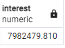

**Total Income:**

SELECT SUM(income) AS Income

FROM cust_detail



**CSS:**

SELECT AVG(cust_satisfaction_score) AS CSS

FROM cust_detail

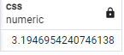

**Amount**

SELECT SUM(total_trans_amt) AS Amount

FROM cc_detail

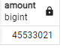

**Count**

SELECT SUM(total_trans_ct) AS Total_Count

FROM cc_detail

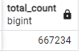

**TOP 5 STATES (GENDER**)

WITH RevenueByState AS (

    SELECT

        cd.state_cd,

        SUM(cc.annual_fees + cc.total_trans_amt + cc.interest_earned) AS total_revenue

    FROM

        cust_detail cd

    JOIN

        cc_detail cc ON cd.client_num = cc.client_num

    GROUP BY

        cd.state_cd

),

TopStates AS (

    SELECT

        state_cd

    FROM

        RevenueByState

    ORDER BY

        total_revenue DESC

    LIMIT 5

)

SELECT

    cd.state_cd,

    cd.gender,

    SUM(cc.annual_fees + cc.total_trans_amt + cc.interest_earned) AS revenue

FROM

    cust_detail cd

JOIN

    cc_detail cc ON cd.client_num = cc.client_num

JOIN

    TopStates ts ON cd.state_cd = ts.state_cd

GROUP BY

    cd.state_cd, cd.gender

ORDER BY

    SUM(cc.annual_fees + cc.total_trans_amt + cc.interest_earned) DESC;

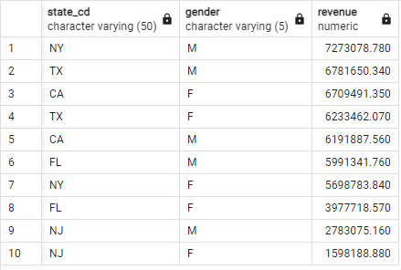

**TOP 5 STATES**

WITH RevenueByState AS (

    SELECT

        cd.state_cd,

        SUM(cc.annual_fees + cc.total_trans_amt + cc.interest_earned) AS total_revenue

    FROM

        cust_detail cd

    JOIN

        cc_detail cc ON cd.client_num = cc.client_num

    GROUP BY

        cd.state_cd

),

TopStates AS (

    SELECT

        state_cd,

        total_revenue

    FROM

        RevenueByState

    ORDER BY

        total_revenue DESC

    LIMIT 5

)

SELECT

    ts.state_cd,

    ts.total_revenue

FROM

    TopStates ts

ORDER BY

    ts.total_revenue DESC;

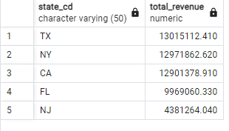

**REVENUE BY WEEK**

SELECT

    DATE_TRUNC('week', cc.week_start_date) AS week_start_date,

    SUM(cc.annual_fees + cc.total_trans_amt + cc.interest_earned) AS total_revenue

FROM

    cc_detail cc

GROUP BY

    DATE_TRUNC('week', cc.week_start_date)

ORDER BY

   week_start_date;

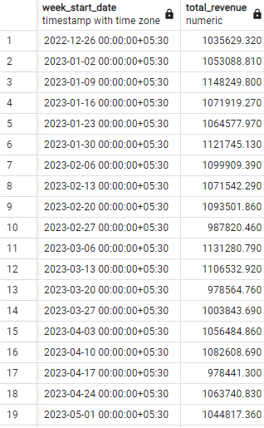

**Revenue by Chip Used**

SELECT

    cc.chip_used,

    SUM(cc.annual_fees + cc.total_transaction_amount + cc.interest_earned) AS total_revenue

FROM

    ccdtail cc

GROUP BY

    cc.chip_used

ORDER BY

    total_revenue DESC;

**Revenue by Card Category**

SELECT

    cc.card_category,

    SUM(cc.annual_fees + cc.total_trans_amt + cc.interest_earned) AS total_revenue

FROM

    cc_detail cc

GROUP BY

    cc.card_category

ORDER BY

    total_revenue DESC;

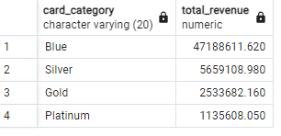

**Revenue by Expenditure Type**

SELECT

    cc.exp_type,

    SUM(cc.annual_fees + cc.total_trans_amt + cc.interest_earned) AS total_revenue

FROM

    cc_detail cc

GROUP BY

    cc.exp_type

ORDER BY

    total_revenue DESC;

